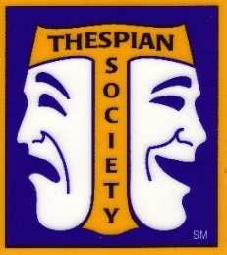
Everything You Need to Know About Being a Thespian

What is the Thespian Society?
The International Thespian Society (ITS) is an organization designed to help students grow their interest and skills in theater. It is also an honor society similar to the National Honor Society (NHS) that honors academic achievement, ITS offers honors and acknowledgements of a students’ dedication to theater. It is ideal for anyone who is considering studying theater in college/university, but is open to anyone who wants to be a part of a state, national, and international theater community. All members receive a monthly theater magazine, Dramatics. College auditions and scholarships are available through ITS as well as numerous awards. Both onstage performers and techies are encouraged to join!
How do I join the Thespian Society?
- Go to dexterdrama.org and click on the Thespian Society tab.
- Fill out the membership form on the “About” page and pay through Payschools as instructed. Joining the society requires a single fee of $100.
This includes monthly Dramatics magazine subscription, annual awards received at end of the year Dexter Drama Gala, and the opportunity to sign up for the annual Thespian Festival which gives access to various categories of performance and technician judication, as well as college auditions and scholarship opportunities.
*You must be a member of the International Thespian Society to attend the festival.

What is the Thespian Festival?

The Michigan Thespian Festival is one of the best parts of becoming a Thespian member. This year, the festival is at the Devos Convention Center in Grand Rapids, Michigan from December 15-17th, a two night stay at a nearby hotel. At the festival, we get to choose from a long list of fun and helpful workshops that help us improve our skills. Some classes are even taught by Broadway professionals. There’s a huge variety of classes for actors and for techies, such as the following:
- acting techniques
- vocal techniques
- various genres of dance
- stage management
- audition techniques
- stage fighting
- And so many more!

While at the festival, we have the opportunity to see numerous plays and musicals right at the university. We eat at the dining hall and get to stay in a hotel together. Best of all, we get to become even closer with our fellow Dexter Drama Club members!
What is an “IE”?
The Michigan Thespian Festival hosts numerous competitions or judications (AKA Independent Events, or “IE”) in a huge variety of categories. You perform in front of judges and are awarded a score, very similar to Choir, Orchestra, and Band Solo and Ensemble. Here are the IE categories you could participate in:
- Solo, duet, or group musical theater
- Monologue
- Group acting
- Solo or group dance
- Costume design
- Costume construction
- Lighting design
- Playwriting
- Sound design
- Stage management
- Makeup design
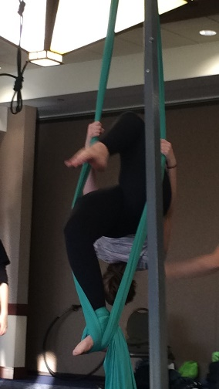
- Scenic design
- Short film
- Theater marketing
There is more information about each specific IE on dexterdrama.org. Check the category on the Festival page for more information on what it takes to participate in that IE! Who is doing what IE will be determined as we get closer to festival.
What does Thespian Festival offer for those who want to pursue theater in college?
At the festival, seniors also have the amazing opportunity to apply/audition for college scholarships. For an extra fee of $25 (Please check requirements! It varies by year), you can perform in front of judges and representatives from a variety of mostly Michigan schools and be offered theater scholarships of varying amounts. Scholarships are given to both student performers and technicians. We can also send two students to audition/interview for the Michigan Thespian Scholarship, which is $500 that can be used for any school related use and is only awarded to TEN students from each state.
What are Tech Olympics?
Tech Olympics is a competitive event offered at Thespian Festival. It takes place during one of the workshop time slots, and participants compete to beat each other’s time in various tech competitions including costume changes, setup of audio and lighting equipment, props change overs, and knot-tying. It is a great opportunity for all techies, and the winner always receives valuable tech equipment for their school. If you’re interested in joining Dexter High School’s Tech Olympics team, come to festival!
How do I sign up for the Thespian Festival?
- The Thespian Festival is open to all members of the society, so make sure you are part of the society first. Follow the steps on front page of this flyer!
- Once you are a Dexter ITS member… Go to dexterdrama.org and click on the Thespian Society tab.
- Click on the Thespian Festival tab. Here you will find even more information about festival and detailed information about college auditions and competitions.
- To sign up for the festival, click on the Payschools button. The festival costs $250 which includes meals.
- Everyone going to festival needs to fill out the Thespian Festival form on the website as well!
- If you are a senior and want to audition for college scholarships at the festival, click on the college scholarships button for more information. Here you will find how to complete and submit your application.
- If you are a senior and want to audition for the Thespian Scholarship, approach Ms. Palmer and more information is also on the Thespian Festival page!

