DHS Drama New York City Trip
March 25th - March 29th 2023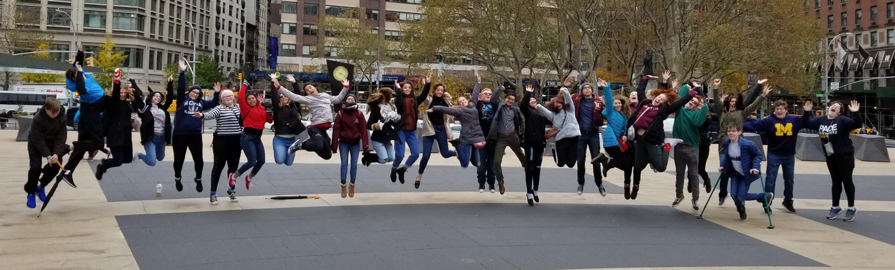
WHO: There is a limit of 30 students - First come, first Serve! Open to Juniors and Seniors only through November 1st, then open enrollment to all underclassmen will begin.
LEAVE: Early Sunday morning at 5:30AM, March 25th, 2023 (We will be taking a Motorcoach Bus to & from NYC). We will arrive in NYC around 6pm on Saturday.
RETURN: Early Wednesday morning, March 29th. The goal is to arrive at 7am.
CHAPERONES: Mrs. Erin Palmer, Mr. Greg LaVoy, Ms. Amanda Webster and others.

PRICE FOR THE TRIP: $1050 paid in 3 installments via Eleyo. You can also pay all at once via Eleyo by selecting each individual installment and then checking out. Please note: Eleyo charges us a fee for every payment processed through that system. We would be happy to accept check payments, made payable to “Dexter Community Schools”. Payments can be delivered to Mrs. Erin Palmer, Mrs. Jodi Helmholtz, or mailed to Dexter Drama Club, PO Box 336 Dexter, MI 48130.
Trip Price will INCLUDE:
3 nights lodging in New York City (Ameritania Hotel)
Tickets for 3 Broadway shows (Shows TBD)
Transportation by motorcaoch to and from NYC
Additional transportation in NYC (Subway, etc.)
Entrance to 9/11 Memorial and/ or MET Museum
Visit to Rockefeller Center: Students Choose “Top of the Rock” or Ice Skating
Tour Price will NOT include:
Meals!!!
Souvenirs and shopping, after theater or hotel room snacks, etc.
Activities from past trips have included:
-A guided tour of Times Square, Rockefeller Center, Central Park, etc
-Touring 9/11 Memorial
-Shopping at Herold Square (Macy's and surrounding area)
-Staten Island Ferry ride (past the Statue of Liberty & NYC skyline) -A visit to Little Italy and Chinatown
-THE BROADWAY SHOWS!!! :)
SEE PAGE TWO FOR IMPORTANT DEPOSIT DUE DATES!!!
Dexter High School's Drama Trip
New York City
March 25th – March 29th, 2023
1st PAYMENT: $350 non-refundable by October 1st.
2nd PAYMENT: $350 non-refundable by November 1st.
3rd PAYMENT: $350 non-refundable by December 1st.
Again, you can pay in installments or all at once. Again, there are NO REFUNDS for payments made.
If there are any questions, please contact Mrs. Erin Palmer at palmere@dexterschools.org or Jodi Helmholtz at helmholtzj@dexterschools.org
Parents and guardians:
This is the 25th annual NYC Theater Trip that the Dexter High School Drama Club has taken. I personally have been to NYC over 25 times. I am comfortable with getting around the city and showing the students the sites of New York. I will provide a detailed itinerary as we get closer to the actual trip. There will also be a meeting in which I will familiarize the students with the “ins and outs” of the trip, which will occur in late March. In the meantime, if you have any questions, feel free to contact me. Thanks for reading!
Mrs. Erin Palmer
Drama and Improv Club Advisor
Dexter High School History Teacher

